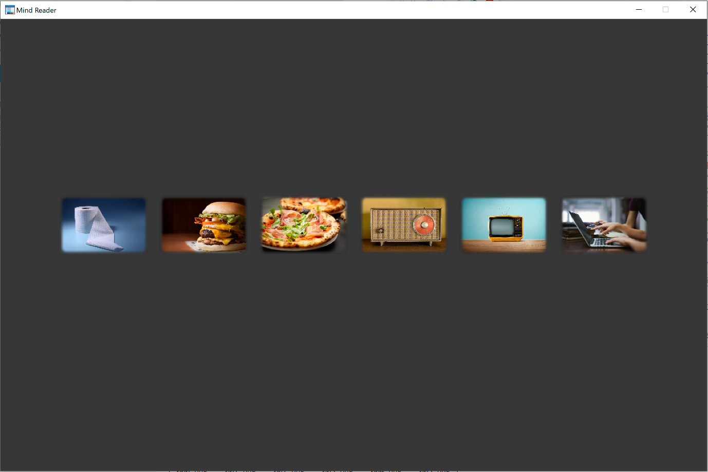

I’m very hungry!

Write

Television

Music

Very hungry

Hungry

Bathroom